UNIT II TRANSPORT LAYER 9
Transport Layer functions – Multiplexing and Demultiplexing – User Datagram Protocol – Transmission Control Protocol – Flow Control – Retransmission Strategies – Congestion Control.
Introduction - Transport-Layer Protocols: UDP – TCP: Connection Management – Flow control -Congestion Control - Congestion avoidance (DECbit, RED) – SCTP – Quality of Service.
2.1 TRANSPORT LAYER FUNCTIONS:
- The transport layer is the fourth layer of the OSI model and is the core of the Internet model.
- It responds to service requests from the session layer and issues service requests to the network Layer.
- The transport layer provides transparent transfer of data between hosts.
- It provides end-to-end control and information transfer with the quality of service needed by the application program.
- It is the first true end-to-end layer, implemented in all End Systems (ES).

- The transport layer is located between the network layer and the application layer.
- The transport layer is responsible for providing services to the application layer;
- It receives services from the network layer.
- The services that can be provided by the transport layer are
1. Process-to-Process Communication
2. Addressing: Port Numbers
3. Encapsulation and Decapsulation
4. Multiplexing and Demultiplexing
5. Flow Control
6. Error Control
7. Congestion Control
1. Process-to-Process Communication
- The Transport Layer is responsible for delivering data to the appropriate application process on the host computers.
- This involves multiplexing of data from different application processes, i.e., forming data packets, and adding source and destination port numbers in the header of each Transport Layer data packet.
- Together with the source and destination IP address, the port numbers constitute a network socket, i.e., an identification address of the process-to-process communication.
2. Addressing: Port Numbers
- Ports are the essential ways to address multiple entities in the same location.
- Using port addressing it is possible to use more than one network-based application at the same time.
- Three types of Port numbers are used:
  - Well-known ports - These are permanent port numbers. They range between 0 to 1023.These port numbers are used by Server Process.
  - Registered ports - The ports ranging from 1024 to 49,151 are not assigned or controlled.
  - Ephemeral ports (Dynamic Ports) – These are temporary port numbers. They range between 49152–65535.These port numbers are used by Client Process.
3. Encapsulation and Decapsulation
- To send a message from one process to another, the transport-layer protocol encapsulates and decapsulates messages.
- Encapsulation happens at the sender site. The transport layer receives the data and adds the transport-layer header.
- Decapsulation happens at the receiver site. When the message arrives at the destination transport layer, the header is dropped and the transport layer delivers the message to the process running at the application layer.
4. Multiplexing and Demultiplexing
- Whenever an entity accepts items from more than one source, this is referred to as multiplexing (many to one).
- Whenever an entity delivers items to more than one source, this is referred to as demultiplexing (one to many).
- The transport layer at the source performs multiplexing
- The transport layer at the destination performs demultiplexing
5. Flow Control
- Flow Control is the process of managing the rate of data transmission between two nodes to prevent a fast sender from overwhelming a slow receiver.
- It provides a mechanism for the receiver to control the transmission speed, so that the receiving node is not overwhelmed with data from transmitting node.
6. Error Control
- Error control at the transport layer is responsible for
1. Detecting and discarding corrupted packets.
2. Keeping track of lost and discarded packets and resending them.
3. Recognizing duplicate packets and discarding them.
4. Buffering out-of-order packets until the missing packets arrive.
- Error Control involves Error Detection and Error Correction
7. Congestion Control
- Congestion in a network may occur if the load on the network (the number of
packets sent to the network) is greater than the capacity of the network (the number of packets a network can handle).
- Congestion control refers to the mechanisms and techniques that control the congestion and keep the load below the capacity.
- Congestion Control refers to techniques and mechanisms that can either prevent
congestion, before it happens, or remove congestion, after it has happened
- Congestion control mechanisms are divided into two categories,
1. Open loop - prevent the congestion before it happens.
2. Closed loop - remove the congestion after it happens.

TRANSPORT LAYER PROTOCOLS:
Three protocols are associated with the Transport layer.
- They are
(1) UDP –User Datagram Protocol
(2) TCP – Transmission Control Protocol
(3) SCTP - Stream Control Transmission Protocol
- Each protocol provides a different type of service and should be used appropriately.
- UDP - UDP is an unreliable connectionless transport-layer protocol used for its simplicity and efficiency in applications where error control can be provided by the application-layer process.
- TCP - TCP is a reliable connection-oriented protocol that can be used in any application where reliability is important.

- SCTP - SCTP is a new transport-layer protocol designed to combine some features of UDP and TCP in an effort to create a better protocol for multimedia communication.

2.2 MULTIPLEXING AND DEMULTIPLEXING IN TRANSPORT LAYER

Multiplexing and Demultiplexing services are provided in almost every protocol architecture ever designed. UDP and TCP perform the demultiplexing and multiplexing jobs by including two special fields in the segment headers: the source port number field and the destination port number field.

Multiplexing -
Gathering data from multiple application processes of the sender, enveloping that data with a header, and sending them as a whole to the intended receiver is called multiplexing.

Demultiplexing -
Delivering received segments at the receiver side to the correct app layer processes is called demultiplexing.

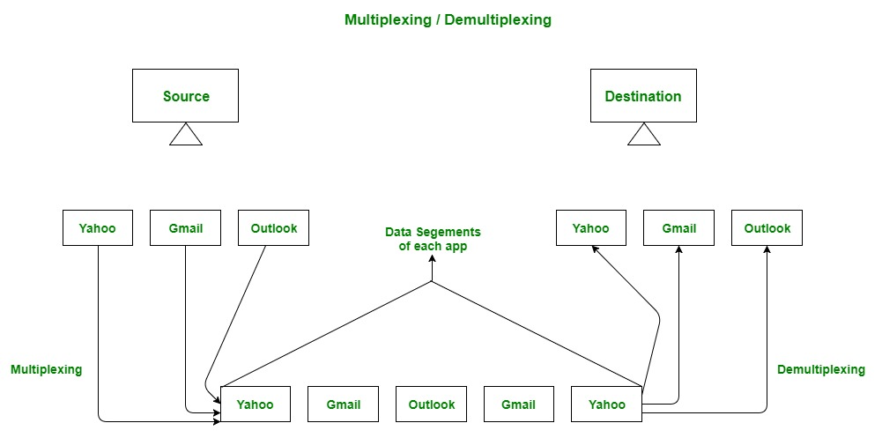
Abstract view of multiplexing and demultiplexing
Multiplexing and demultiplexing are the services facilitated by the transport layer of the OSI model.
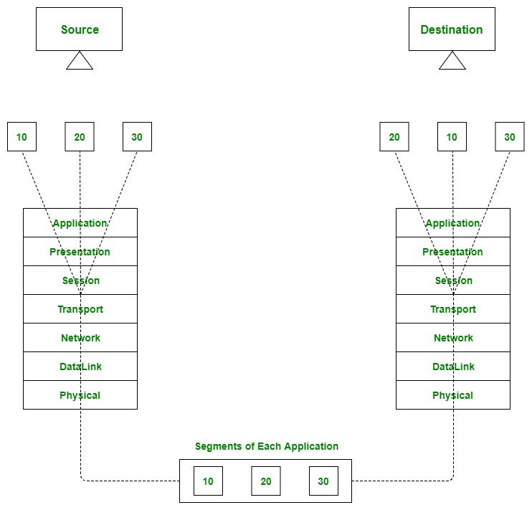
Transport layer- junction for multiplexing and demultiplexing

There are two types of multiplexing and Demultiplexing :
- Connectionless Multiplexing and Demultiplexing
- Connection-Oriented Multiplexing and Demultiplexing
How Multiplexing and Demultiplexing is done -
For sending data from an application on the sender side to an application at the destination side, the sender must know the IP address of the destination and port number of the application (at the destination side) to which he wants to transfer the data. Block diagram is shown below:

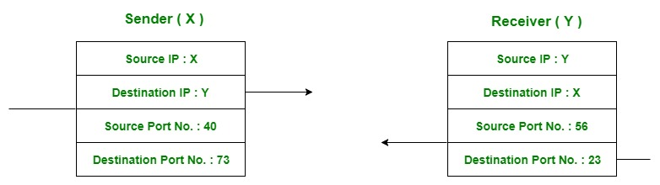
Transfer of packet between applications of sender and receiver
Let us consider two messaging apps that are widely used nowadays viz. Hike and WhatsApp. Suppose A is the sender and B is the receiver. Both sender and receiver have these applications installed in their system (say smartphone). Suppose A wants to send messages to B in WhatsApp and hike both. In order to do so, A must mention the IP address of B and destination port number of the WhatsApp while sending the message through the WhatsApp application. Similarly, for the latter case, A must mention the IP address of B and the destination port number of the hike while sending the message.

Now the messages from both the apps will be wrapped up along with appropriate headers(viz. source IP address, destination IP address, source port no, destination port number) and sent as a single message to the receiver. This process is called multiplexing. At the destination, the received message is unwrapped and constituent messages (viz messages from a hike and WhatsApp application) are sent to the appropriate application by looking to the destination the port number. This process is called demultiplexing. Similarly, B can also transfer the messages to A.

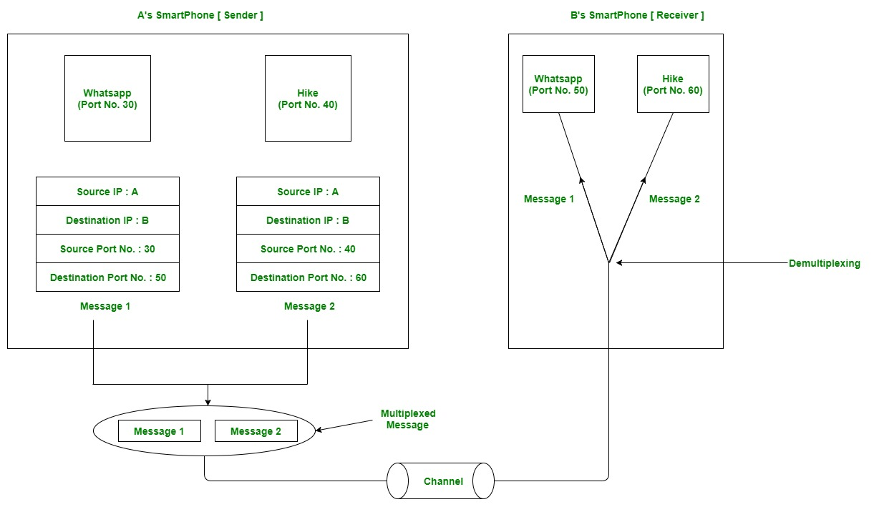
Message transfer using WhatsApp and hike messaging application

2.3 USER DATAGRAM PROTOCOL (UDP)
- User Datagram Protocol (UDP) is a connectionless, unreliable transport protocol UDP adds process-to-process communication to best-effort service provided by IP.
- UDP is a very simple protocol using a minimum of overhead.
- UDP is a simple demultiplexer, which allows multiple processes on each host to communicate.
- UDP does not provide flow control, reliable or ordered delivery.
- UDP can be used to send small message where reliability is not expected.
- Sending a small message using UDP takes much less interaction between the sender and receiver.
- UDP allow processes to indirectly identify each other using an abstract locator called port or mailbox
UDP PORTS:
- Processes (server/client) are identified by an abstract locator known as port.
- Server accepts message at well-known port.
- Some well-known UDP ports are 7–Echo, 53–DNS, 111–RPC, 161–SNMP, etc.
- < port, host > pair is used as key for demultiplexing.
- Ports are implemented as a message queue.
- When a message arrives, UDP appends it to end of the queue.
- When queue is full, the message is discarded.
- When a message is read, it is removed from the queue.
- When an application process wants to receive a message, one is removed from the front of the queue.
- If the queue is empty, the process blocks until a message becomes available.
UDP DATAGRAM (PACKET) FORMAT:
- UDP packets are known as user datagrams .
- These user datagrams, have a fixed-size header of 8 bytes made of four fields, each of 2 bytes (16 bits).
Source Port Number:
- Port number used by process on source host with 16 bits long.
- If the source host is client (sending request) then the port number is an temporary one requested by the process and chosen by UDP.
- If the source is server (sending response) then it is well known port number.
Destination Port Number:
- Port number used by process on Destination host with 16 bits long.
- If the destination host is the server (a client sending request) then the port number is a well-known port number.
- If the destination host is client (a server sending response) then port number is an temporary one copied by server from the request packet.
Length:
- This field denotes the total length of the UDP Packet (Header plus data)
- The total length of any UDP datagram can be from 0 to 65,535 bytes.
Checksum:
- UDP computes its checksum over the UDP header, the contents of the message
body, and something called the pseudoheader.
- The pseudoheader consists of three fields from the IP header—protocol number,
source IP address, destination IP address plus the UDP length field.
Data:
- Data field defines the actual payload to be transmitted.
- Its size is variable.
UDP SERVICES:
Process-to-Process Communication:
- UDP provides process-to-process communication using socket addresses, a combination of IP addresses and port numbers.
Connectionless Services:
- UDP provides a connectionless service.
- There is no connection establishment and no connection termination.
- Each user datagram sent by UDP is an independent datagram.
- There is no relationship between the different user datagrams even if they are coming from the same source process and going to the same destination program.
- The user datagrams are not numbered.
- Each user datagram can travel on a different path.
Flow Control:
- UDP is a very simple protocol.
- There is no flow control, and hence no window mechanism.
- The receiver may overflow with incoming messages.
- The lack of flow control means that the process using UDP should provide for this
service, if needed.
Error Control:
- There is no error control mechanism in UDP except for the checksum.
- This means that the sender does not know if a message has been lost or duplicated.
- When the receiver detects an error through the checksum, the user datagram is
silently discarded.
- The lack of error control means that the process using UDP should provide for this
service, if needed.
Checksum:
- UDP checksum calculation includes three sections: a pseudoheader, the UDP header,
and the data coming from the application layer.
- The pseudoheader is the part of the header in which the user datagram is to be
encapsulated with some fields filled with 0s.
Optional Inclusion of Checksum
- The sender of a UDP packet can choose not to calculate the checksum.
- In this case, the checksum field is filled with all 0s before being sent.
- In the situation where the sender decides to calculate the checksum, but it happens that the result is all 0s, the checksum is changed to all 1s before the packet is sent.
- In other words, the sender complements the sum two times.
Congestion Control:
- Since UDP is a connectionless protocol, it does not provide congestion control.
- UDP assumes that the packets sent are small and sporadic(occasionally or at irregular intervals) and cannot create congestion in the network.
- This assumption may or may not be true, when UDP is used for interactive real-time
transfer of audio and video.
Encapsulation and Decapsulation:
- To send a message from one process to another, the UDP protocol encapsulates and
decapsulates messages.
Queuing:
- In UDP, queues are associated with ports.
- At the client site, when a process starts, it requests a port number from the operating
System.
- Some implementations create both an incoming and an outgoing queue associated
with each process.
- Other implementations create only an incoming queue associated with each process.
Multiplexing and Demultiplexing:
- In a host running a transport protocol suite, there is only one UDP but possibly
several processes that may want to use the services of UDP.
- To handle this situation, UDP multiplexes and demultiplexes.
APPLICATIONS OF UDP
- UDP is used for management processes such as SNMP.
- UDP is used for route updating protocols such as RIP.
- UDP is a suitable transport protocol for multicasting. Multicasting capability is
embedded in the UDP software
- UDP is suitable for a process with internal flow and error control mechanisms such as Trivial File Transfer Protocol (TFTP).
- UDP is suitable for a process that requires simple request-response communication
with little concern for flow and error control.
- UDP is normally used for interactive real-time applications that cannot tolerate uneven delay between sections of a received message.
2.4 TRANSMISSION CONTROL PROTOCOL(TCP)
- TCP is a reliable, connection-oriented, byte-stream protocol.
- TCP guarantees the reliable, in-order delivery of a stream of bytes. It is a full-duplex protocol, meaning that each TCP connection supports a pair of byte streams, one flowing in each direction.
- TCP includes a flow-control mechanism for each of these byte streams that allow the receiver to limit how much data the sender can transmit at a given time.
- TCP supports a demultiplexing mechanism that allows multiple application programs on any given host to simultaneously carry on a conversation with their peers.
- TCP also implements congestion-control mechanism. The idea of this mechanism is to prevent sender from overloading the network.
- Flow control is an end-to-end issue, whereas congestion control is concerned with how host and network interact
TCP SERVICES
Process-to-Process Communication:
- TCP provides process-to-process communication using port numbers.
Stream Delivery Service:
- TCP is a stream-oriented protocol.
- TCP allows the sending process to deliver data as a stream of bytes and allows the receiving process to obtain data as a stream of bytes.
- TCP creates an environment in which the two processes seem to be connected by an
imaginary “tube” that carries their bytes across the Internet.
- The sending process produces (writes to) the stream and the receiving process
consumes (reads from) it.
Full-Duplex Communication:
- TCP offers full-duplex service, where data can flow in both directions at the same
time.
- Each TCP endpoint then has its own sending and receiving buffer, and segments move in both directions.
Multiplexing and Demultiplexing:
- TCP performs multiplexing at the sender and demultiplexing at the receiver.
Connection-Oriented Service:
- TCP is a connection-oriented protocol.
- A connection needs to be established for each pair of processes.
- When a process at site A wants to send to and receive data from another process at site B, the following three phases occur:
1. The two TCP’s establish a logical connection between them.
2. Data are exchanged in both directions.
3. The connection is terminated.
Reliable Service:
- TCP is a reliable transport protocol.
- It uses an acknowledgment mechanism to check the safe and sound arrival of data.

TCP SEGMENT
- A packet in TCP is called a segment.
- Data unit exchanged between TCP peers are called segments.
- A TCP segment encapsulates the data received from the application layer.
- The TCP segment is encapsulated in an IP datagram, which in turn is encapsulated in a frame at the data-link layer.
- TCP is a byte-oriented protocol, which means that the sender writes bytes into a TCP connection and the receiver reads bytes out of the TCP connection.
- TCP does not, itself, transmit individual bytes over the Internet.
- TCP on the source host buffers enough bytes from the sending process to fill a reasonably sized packet and then sends this packet to its peer on the destination host.
- TCP on the destination host then empties the contents of the packet into a receive buffer, and the receiving process reads from this buffer at its leisure.
- TCP connection supports byte streams flowing in both directions.
- The packets exchanged between TCP peers are called segments, since each one carries a segment of the byte stream.
TCP PACKET FORMAT
- Each TCP segment contains the header plus the data.
- The segment consists of a header of 20 to 60 bytes, followed by data from the application program.
- The header is 20 bytes if there are no options and up to 60 bytes if it contains options.
SrcPort and DstPort―port number of source and destination process.
SequenceNum―contains sequence number, i.e. first byte of data segment.
Acknowledgment― byte number of segment, the receiver expects next.
HdrLen―Length of TCP header as 4-byte words.
Flags― contains six control bits known as flags.
o URG — segment contains urgent data.
o ACK — value of acknowledgment field is valid.
o PUSH — sender has invoked the push operation.
o RESET — receiver wants to abort the connection.
o SYN — synchronize sequence numbers during connection establishment.
o FIN — terminates the TCP connection.
Advertised Window―defines receiver’s window size and acts as flow control.
Checksum―It is computed over TCP header, Data, and pseudo header containing IP fields
(Length, SourceAddr & DestinationAddr).
UrgPtr ― used when the segment contains urgent data. It defines a value that must be
added to the sequence number.
Options - There can be up to 40 bytes of optional information in the TCP header

TCP CONNECTION MANAGEMENT
- TCP is connection-oriented.
- A connection-oriented transport protocol establishes a logical path between the source and destination.
- All of the segments belonging to a message are then sent over this logical path.
- In TCP, connection-oriented transmission requires three phases: Connection Establishment, Data Transfer and Connection Termination.
Connection Establishment:
- While opening a TCP connection the two nodes(client and server) want to agree on a set of parameters.
- The parameters are the starting sequence numbers that is to be used for their respective byte streams.
- Connection establishment in TCP is a three-way handshaking.
1. Client sends a SYN segment to the server containing its initial sequence number (Flags
= SYN, SequenceNum = x)
2. Server responds with a segment that acknowledges client’s segment and specifies its
initial sequence number (Flags = SYN + ACK, ACK = x + 1 SequenceNum = y).
3. Finally, client responds with a segment that acknowledges server’s sequence number
(Flags = ACK, ACK = y + 1).
- The reason that each side acknowledges a sequence number that is one larger than the one sent is that the Acknowledgment field actually identifies the “next sequence number expected,”
- A timer is scheduled for each of the first two segments, and if the expected response is not received, the segment is retransmitted.
Data Transfer:
- After connection is established, bidirectional data transfer can take place.
- The client and server can send data and acknowledgments in both directions.
- The data traveling in the same direction as an acknowledgment are carried on the same segment.
- The acknowledgment is piggybacked with the data.
Connection Termination:
- Connection termination or teardown can be done in two ways: Three-way Close and Half-Close
- Three-way Close—Both client and server close simultaneously.
  - Client sends a FIN segment.
  - The FIN segment can include last chunk of data.
  - Server responds with FIN + ACK segment to inform its closing.
  - Finally, client sends an ACK segment
- Half-Close—Client stops sending but receives data.
- Client half-closes the connection by sending a FIN segment.
- Server sends an ACK segment.
- Data transfer from client to the server stops.
- After sending all data, server sends FIN segment to client, which is acknowledged by the client.
STATE TRANSITION DIAGRAM:
- To keep track of all the different events happening during connection establishment, connection termination, and data transfer, TCP is specified as the finite state machine (FSM).
- The transition from one state to another is shown using directed lines.
- States involved in opening and closing a connection is shown above and below ESTABLISHED state respectively.

States Involved in TCP:

Opening a TCP Connection:
1. Server invokes a passive open on TCP, which causes TCP to move to LISTEN state
2. Client does an active open, which causes its TCP to send a SYN segment to the server
and move to SYN_SENT state.
3. When SYN segment arrives at the server, it moves to SYN_RCVD state and responds
with a SYN + ACK segment.
4. Arrival of SYN + ACK segment causes the client to move to ESTABLISHED state
and sends an ACK to the server.
5. When ACK arrives, the server finally moves to ESTABLISHED state.
Closing a TCP Connection:
Client / Server can independently close its half of the connection or simultaneously.
Transitions from ESTABLISHED to CLOSED state are:
One side close:
ESTABLISHED → FIN_WAIT_1 → FIN_WAIT_2 → TIME_WAIT → CLOSED
Other side close:
ESTABLISHED → CLOSE_WAIT → LAST_ACK → CLOSED
Simultaneous close:
ESTABLISHED → FIN_WAIT_1 → CLOSING → TIME_WAIT → CLOSED

2.5 TCP FLOW CONTROL
- TCP flow control balances the rate a producer creates data with the rate a consumer can use the data.
- TCP uses a variant of sliding window known as adaptive flow control that:
o guarantees reliable delivery of data
o ensures ordered delivery of data
o enforces flow control at the sender
Advertised Window:
- To achieve flow control, TCP uses the AdvertisedWindow field.
- Receiver advertises its window size to the sender using AdvertisedWindow field.
- Sender thus cannot have unacknowledged data greater than AdvertisedWindow
Send Buffer:
- Sending TCP maintains send buffer which contains 3 segments
(1) acknowledged data
(2) unacknowledged data
(3) data to be transmitted.
- Send buffer maintains three pointers
(1) LastByteAcked, (2) LastByteSent, and (3) LastByteWritten
such that:
LastByteAcked ≤ LastByteSent ≤ LastByteWritten
- A byte can be sent only after being written and only a sent byte can be acknowledged.
- Bytes to the left of LastByteAcked are not kept as it had been acknowledged.
Working of Flow Control in TCP:
- Size of send and receive buffer is MaxSendBuffer and MaxRcvBuffer respectively.
- Sending TCP prevents overflowing of send buffer by maintaining
LastByteWritten − LastByteAcked ≤ MaxSendBuffer
- Receiving TCP avoids overflowing its receive buffer by maintaining
LastByteRcvd − LastByteRead ≤ MaxRcvBuffer
- Receiver throttles the sender by having AdvertisedWindow based on free space available for buffering.
AdvertisedWindow = MaxRcvBuffer − ((NextByteExpected − 1) – LastByteRead)
- Sending TCP adheres to AdvertisedWindow by computing EffectiveWindow that limits how much data it should send.
EffectiveWindow = AdvertisedWindow − (LastByteSent − LastByteAcked)
- When data arrives, LastByteRcvd moves to its right and AdvertisedWindow shrinks.
- Receiver acknowledges only, if preceding bytes have arrived.
- AdvertisedWindow expands when data is read by the application.
- If data is read as fast as it arrives then AdvertisedWindow = MaxRcvBuffer
- If data is read slowly, it eventually leads to a AdvertisedWindow of size 0.
- AdvertisedWindow field is designed to allow sender to keep the pipe full.

2.6 RETRANSMISSION STRATEGIES
Adaptive Retransmission
TCP guarantees the reliable delivery of data, it retransmits each segment if an ACK is not received in a certain period of time. TCP sets this timeout as a function of the RTT it expects between the two ends of the connection. Unfortunately, given the range of possible RTTs between any pair of hosts in the Internet, as well as the variation in RTT between the same two hosts over time, choosing an appropriate timeout value is not that easy. To address this problem, TCP uses an adaptive retransmission mechanism.

The algorithm for computing a timeout value between a pair of hosts. This is the algorithm that was originally described in the TCP speciﬁcation—and the following description presents it in those terms—but it could be used by any end-to-end protocol.
The idea is to keep a running average of the RTT and then to compute the timeout as a function of this RTT. Speciﬁcally, every time TCP sends a data segment, it records the time. When an ACK for that segment arrives, TCP reads the time again, and then takes the difference between these two times as a SampleRTT. TCP then computes an EstimatedRTT as a weighted average between the previous estimate and this new sample.
That is,
The parameter α is selected to smooth the EstimatedRTT. A small α tracks changes in the RTT but is perhaps too heavily inﬂuenced by temporary ﬂuctuations. On the other hand, a large α is more stable but perhaps not quick enough to adapt to real changes. The original TCP speciﬁcation ecommended a setting of α between 0.8 and 0.9. TCP then uses EstimatedRTT to compute the timeout in a rather conservative way:

Karn/Partridge Algorithm
The problem was that an ACK does not really acknowledge a transmission; it actually acknowledges the receipt of data. In other words, whenever a segment is retransmitted and then
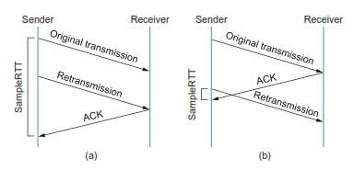
Associating the ACK with (a) original transmission versus (b) retransmission.
an ACK arrives at the sender, it is impossible to determine if this ACK should be associated with the ﬁrst or the second transmission of the segment for the purpose of measuring the sample RTT. It is necessary to know which transmission to associate it with so as to compute an accurate Sample RTT.As illustrated in above figure if you assume that the ACK is for the original transmission but it was really for the second, then the SampleRTT is too large (a); if you assume that the ACK is for the second transmission but it was actually for the ﬁrst, then the SampleRTT is too small (b).

Jacobson/Karels Algorithm

The Karn/Partridge algorithm was introduced at a time when the Internet was suffering from high levels of network congestion. Their approach was designed to ﬁx some of the causes of that congestion, but, although it was an improvement, the congestion was not eliminated. The main problem with the original computation is that it does not take the variance of the sample RTTs into account. Intuitively, if the variation among samples is small, then the EstimatedRTT can be better trusted and there is no reason for multiplying this estimate by 2 to compute the timeout. On the other hand, a large variance in the samples suggests that the timeout value should not be too tightly coupled to the EstimatedRTT.
In the new approach, the sender measures a new SampleRTT as before. It then folds this new sample into the timeout calculation as follows:

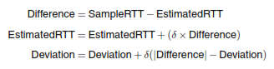
where δ is a fraction between 0 and 1. That is, we calculate both the mean RTT and the variation in that mean.
TCP then computes the timeout value as a function of both Estimated RTT and Deviation as follows:
where based on experience, µ is typically set to 1 and φ is set to 4. Thus, when the variance is small, TimeOut is close to EstimatedRTT; a large variance causes the Deviation termto dominate the calculation.

2.7 CONGESTION CONTROL
- Congestion occurs if load (number of packets sent) is greater than capacity of the network (number of packets a network can handle).
- When load is less than network capacity, throughput increases proportionally.
- When load exceeds capacity, queues become full and the routers discard some packets and throughput declines sharply.
- When too many packets are contending for the same link
o The queue overflows
o Packets get dropped
o Network is congested
- Network should provide a congestion control mechanism to deal with such a situation.
- TCP maintains a variable called CongestionWindow for each connection.
- TCP Congestion Control mechanisms are:
1. Additive Increase / Multiplicative Decrease (AIMD)
2. Slow Start
3. Fast Retransmit and Fast Recovery
Additive Increase / Multiplicative Decrease (AIMD):
- TCP source initializes CongestionWindow based on congestion level in the network.
- Source increases CongestionWindow when level of congestion goes down and decreases the same when level of congestion goes up.
- TCP interprets timeouts as a sign of congestion and reduces the rate of transmission.
- On timeout, source reduces its CongestionWindow by half, i.e., multiplicative decrease.
- For example, if CongestionWindow = 16 packets, after timeout it is 8.
- Value of CongestionWindow is never less than maximum segment size (MSS).
- When ACK arrives CongestionWindow is incremented marginally, i.e., additive increase.
Increment = MSS × (MSS / CongestionWindow)
CongestionWindow += Increment
- For example, when ACK arrives for 1 packet, 2 packets are sent. When ACK for both packets arrive, 3 packets are sent and so on.
- CongestionWindow increases and decreases throughout lifetime of the connection
- When CongestionWindow is plotted as a function of time, a saw-tooth pattern
results.
Slow Start:
- Slow start is used to increase CongestionWindow exponentially from a cold start.
- Source TCP initializes CongestionWindow to one packet.
- TCP doubles the number of packets sent every RTT on successful transmission.
- When ACK arrives for first packet TCP adds 1 packet to CongestionWindow and sends two packets.
- When two ACKs arrive, TCP increments CongestionWindow by 2 packets and sends four packets and so on.
- Instead of sending entire permissible packets at once (bursty traffic), packets are sent in a phased manner, i.e., slow start.
- Initially TCP has no idea about congestion, henceforth it increases CongestionWindow rapidly until there is a timeout.
- On timeout:
CongestionThreshold = CongestionWindow/ 2
CongestionWindow = 1
- Slow start is repeated until CongestionWindow reaches CongestionThreshold and thereafter 1 packet per RTT.
- The congestion window trace will look like
Fast Retransmit And Fast Recovery:
- TCP timeouts led to long periods of time during which the connection went dead while waiting for a timer to expire.
- Fast retransmit is a heuristic approach that triggers retransmission of a dropped
packet sooner than the regular timeout mechanism. It does not replace regular
timeouts.
- When a packet arrives out of order, receiving TCP resends the same
acknowledgment (duplicate ACK) it sent last time.
- When three duplicate ACK arrives at the sender, it infers that corresponding packet
may be lost due to congestion and retransmits that packet. This is called fast
retransmit before regular timeout.
- When packet loss is detected using fast retransmit, the slow start phase is replaced by
additive increase, multiplicative decrease method. This is known as fast recovery.
- Instead of setting CongestionWindow to one packet, this method uses the ACKs that
are still in pipe to clock the sending of packets.
- Slow start is only used at the beginning of a connection and after regular timeout. At
other times, it follows a pure AIMD pattern.
- For example, packets 1 and 2 are received whereas packet 3 gets lost.
o Receiver sends a duplicate ACK for packet 2 when packet 4 arrives.
o Sender receives 3 duplicate ACKs after sending packet 6 retransmits packet 3.
o When packet 3 is received, receiver sends cumulative ACK up to packet 6.
- The congestion window trace will look like
TCP CONGESTION AVOIDANCE
- Congestion avoidance mechanisms prevent congestion before it actually occurs.
- These mechanisms predict when congestion is about to happen and then to reduce the
rate at which hosts send data just before packets start being discarded.
- TCP creates loss of packets in order to determine bandwidth of the connection.
- Routers help the end nodes by intimating when congestion is likely to occur.
- Congestion-avoidance mechanisms are:
o DEC bit - Destination Experiencing Congestion Bit
o RED - Random Early Detection
DEC Bit (Destination Experiencing Congestion Bit)
- The first mechanism developed for use on the Digital Network Architecture (DNA).
- The idea is to evenly split the responsibility for congestion control between the routers and the end nodes.
- Each router monitors the load it is experiencing and explicitly notifies the end nodes when congestion is about to occur.
- This notification is implemented by setting a binary congestion bit in the packets that flow through the router; hence the name DECbit.
- The destination host then copies this congestion bit into the ACK it sends back to the source.
- The Source checks how many ACK has DEC bit set for previous window packets.
- If less than 50% of ACK have DEC bit set, then source increases its congestion window by 1 packet
- Otherwise, decreases the congestion window by 87.5%.
- Finally, the source adjusts its sending rate so as to avoid congestion.
- Increase by 1, decrease by 0.875 rule was based on AIMD for stabilization.
- A single congestion bit is added to the packet header.
- Using a queue length of 1 as the trigger for setting the congestion bit.
- A router sets this bit in a packet if its average queue length is greater than or equal to 1 at the time the packet arrives.
Computing average queue length at a router using DEC bit:

- Average queue length is measured over a time interval that includes the
Average Queue Length = last busy + last idle cycle + current busy cycle.
- It calculates the average queue length by dividing the curve area with time interval.
RED(Random Early Detection)
- The second mechanism of congestion avoidance is called as Random Early
Detection (RED).
- Each router is programmed to monitor its own queue length, and when it detects that
there is congestion, it notifies the source to adjust its congestion window.
- RED differs from the DEC bit scheme by two ways:
a. In DECbit, explicit notification about congestion is sent to source, whereas
RED implicitly notifies the source by dropping a few packets.
b. DECbit may lead to tail drop policy, whereas RED drops packet based on
drop probability in a random manner.
- Drop each arriving packet with some drop probability whenever the queue
length exceeds some drop level. This idea is called early random drop.
Computation of average queue length using RED:
AvgLen = (1 − Weight) × AvgLen + (Weight × SampleLen)
where 0 < Weight < 1
SampleLen – is the length of the queue when a sample measurement is made.
- The queue length is measured every time a new packet arrives at the gateway.
- RED has two queue length thresholds that trigger certain activity: MinThreshold and MaxThreshold
- When a packet arrives at a gateway it compares Avglen with these two values according to the following rules.

